BOOK INFORMATION

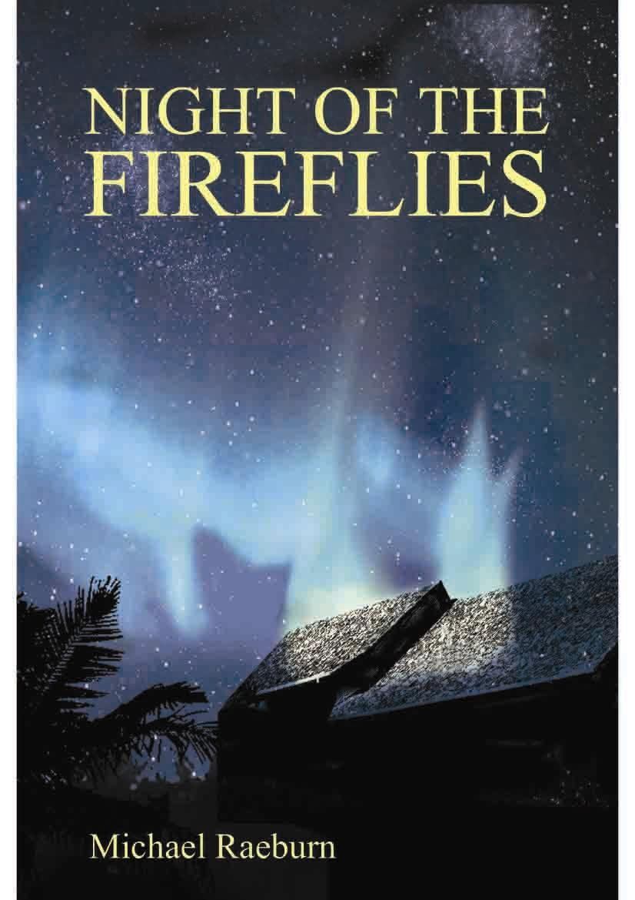
NIGHT OF THE FIREFLIES
Michael Raeburn

In a story full of twists and turns, Night of the Fireflies follows in the great tradition of African culture in which real and unreal are merely two sides of the same coin. Set in the nightmarish landscape of the traumatized city of Maputo, capital of Mozambique, the story unfolds over 15 days in the Christmas of 1984. On a desperate quest to find his lost lover in the war-torn city, the narrator becomes a guest in the household of Rainer , a highly eccentric man of mixed race whose psychic powers are startlingly revealed in his extraordinary healing of a dying soldier.

A testament to experience that lies beyond the confines of the ‘normal’, the novel explores the so-called supernatural world in which psychic energy is a powerful tool for discovery. Repelled at first by Rainer’s physical presence and bizarre behaviour, the narrator eventually succumbs to his charisma and colludes in Rainer’s elaborate devising of his own suicide. Curiosity becomes his best tactic for survival, allowing him to keep peeling away the layers of mystery that surround his host and to try and comprehend the complexities of Rainer’s scientifically based cosmology and the dangerous political intrigue that lies behind it.

Strikingly original in subject and concept, Night of the Fireflies is filmmaker Michael Raeburn’s second novel. It is engrossing reading, taking the reader on a journey that ends in a new consciousness that enables the narrator to let go of his lover, to leave Mozambique and write this story – exactly as Rainer had planned.

About the author:
Michael Raeburn was born in Cairo and grew up in Zimbabwe. He has written and directed numerous feature films and documentaries, many of which have received prestigious awards. They include: ‘The Grass is Singing’, ‘Winds of Rage’, ‘Home Sweet Home’ and ‘Jit’, which is based on his own novel of the same name. He has also written a book of short stories entitled Black Fire! (Random House). He is presently making a film adaptation of Marlene van Niekerk’s novel Triomf.

978-0-86486-686-8 / 0-86486-686-0  R115.00  240 pp  Softcover  November 2006

BUY THIS BOOK : orders@centralbooks.com www.centralbooks.co.uk Phone: 44 - 20889864854

